**Geotab Troubleshooting Instructions**

1. Locate Geotab Telematic – Geotabs are installed on the diagnostic port. Search that area. If the Geotab is installed there, you may also find the Nexiq Bluetooth ELD Device if the vehicle requires driver logs (this is easily identifiable if the vehicle has a sticker on the exterior or interior identifying it is logging-capable). All Commercial Rental medium- and heavy-duty vehicles require both devices.

Geotab Device: Nexiq Bluetooth ELD Devices:

Do not work on ELD

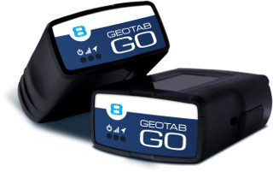 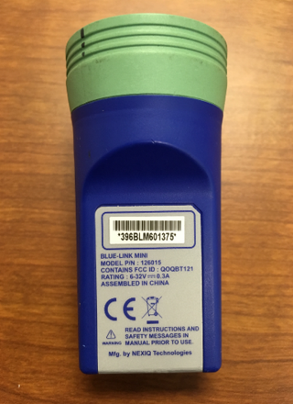 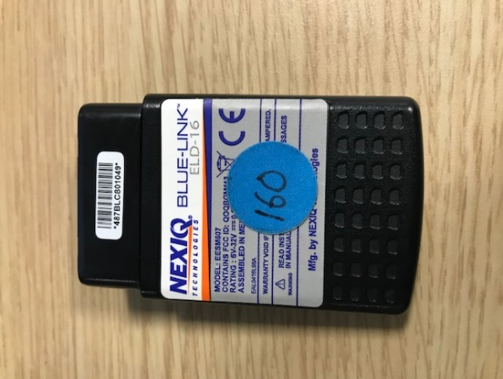

**If you are working on the International MV vehicles, you may find the Geotab hooked to one of two places:

* 1. there is a second diagnostic plug hidden in the knee panel below the steering wheel:

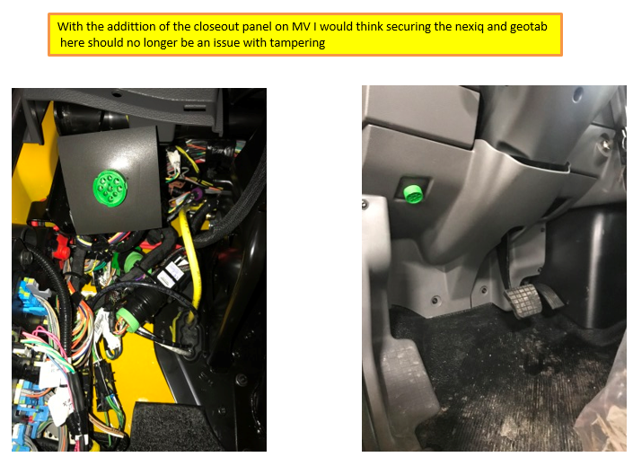

* 1. In Model Year 2021, it may be located in the center of the dash above the cup holders attached to the RP1226 connector:

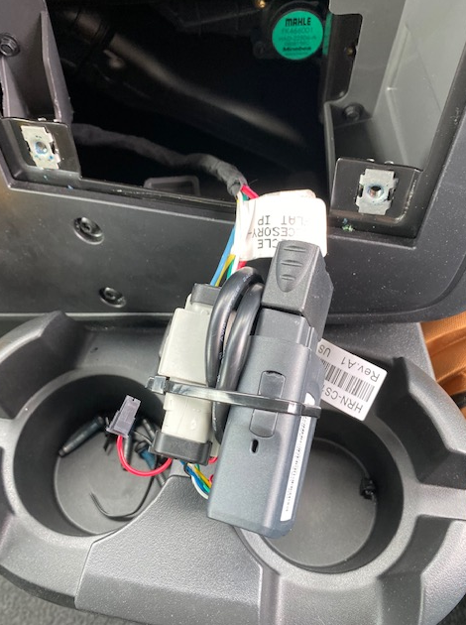

**If the Geotab is missing, install a spare Geotab from your inventory or order a new one by going to** <https://install.assuredtelematics.com/penske/>  **and clicking on the Order Device button. If you have a device with a serial number that starts with G7, please do not install it. It will need to be replaced with a newer device with a serial number that starts with G8 or G9. Once you have the correct device, proceed to step 3.**

**IMPORTANT: If you find any additional devices, please leave them in the vehicle, they may be owned by a customer and Penske will incur additional costs to restore these back to the vehicle.**

1. Check that the device serial number does not start with a “G6” or “G7”. If it does, stop what you are doing. This device has a discontinued 3G modem that will no longer work. To order a new device go to <https://install.assuredtelematics.com/penske/> and click on the “Order Device” button.
2. Perform a hard reset of the Geotab device – To perform the reset, unplug the Geotab system. Wait 15 seconds and plug the Geotab back in. While the Geotab reboots, check all of the Y-cable connections to make sure they are secure.
3. Photograph the Serial Number of the device – Please take a photo of the serial number of the device and add it as a job attachment in Servicenet. Also, make sure to enter the serial number into the RO notes.
4. Check the LEDs on the device – There should be three LED lights, RED = Ignition ON, GREEN = Cellular communication, BLUE = GPS location lock. If all of the LEDs illuminate you are done and can skip to step 5.
   1. If some but not all LEDs light up, take the truck on a 5-minute drive. If the all the LEDs light up, you can skip to step 5.
   2. If no LEDs are illuminated it is most likely a power problem, possibly a blown fuse. Before checking any fuses, an easy test is to place the device in another vehicle’s diagnostic port and verify if the LEDs illuminate correctly. This will identify if it is a device issue or a vehicle issue. If it is power issue, it could be any fuse.
   3. If neither a or b worked, the system needs to be replaced. Please use the spare in your inventory and install it into the harness. Please start back at Step 3 to ensure the replacement device is working.
5. Confirm the device started reporting – Go to <https://install.assuredtelematics.com/penske/> and enter in the required information. Once submitted, you will get one of the following screens:

Success, move to next step:

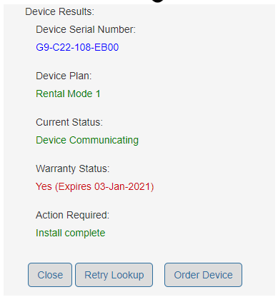

Failure, retry troubleshooting and if it appears again, replace the device with one from your

inventory or use the Order Device button to order a new device:

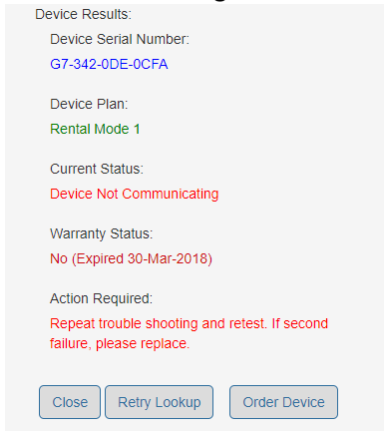

If you get the below screen, click on the Activate button and then try again a few hours

later. If it does not activate, you will need to replace the device. You can use one from stock or

click on the Order Device button:

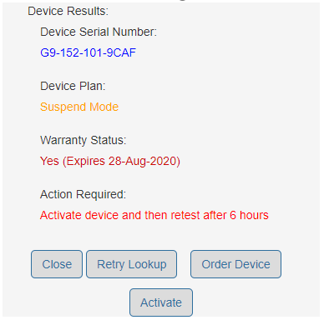

If you get the below error while you are filling out the form, it means one of two things

happened:

* 1. The device you installed in the truck is old and has been terminated and will not work.
  2. The device was purchased from the wrong reseller. Please try and return that device and order one by clicking on the Order Device button.

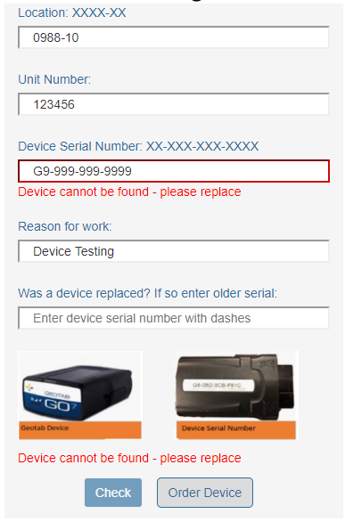

If you have questions while troubleshooting, please contact Geotab/Assured Telematics at 720-515-3535 or [support@assuredtelematics.com](mailto:support@assuredtelematics.com).

Please dispose of any defective devices.

1. Finish the repair – Once the Geotab is confirmed to be working, please check that the Nexiq Bluetooth ELD device is still working. Then resecure the Geotab with a zip tie or Velcro tie and replace the devices where you found them. Make sure the harness is not pinched.

If there are any questions, please contact Penske’s Onboard Systems Managers at Penske.OSMs@penske.com.